EE 603

SPECTRAL ESTIMATION

TAKE HOME EXAM II

e1124346
Salim SIRTKAYA

09 December 2004

General Information about the report
In this report you can find the solutions to the exercises given in ‘INTRODUCTION to SPECTRAL ANALYSIS’ book. These exercises are:
- Exercise C3.16 : Comparison of AR, ARMA and Periodogram methods for ARMA Signals
- Exercise C3.17 : AR and ARMA Estimators for Line Spectral Estimation
The algorithms are implemented in .MATLAB 6.0 .
The spectral estimates are plotted as H(w)/H(0). The true PSD is plotted at every figure with bold red line. The average spectral estimates are plotted at some figures with bold blue line.

Exercise C3.16: Comparison of AR, ARMA and Periodogram Methods for ARMA Signals

Part 1 : Broadband ARMA Process:
The filter coefficients of the ARMA process are given as follows:
a(1)=1; a(2)=-1.3817; a(3)=1.5632; a(4)=-0.8843; a(5)=0.4096;
b(1)=1; b(2)=0.3544; b(3)=0.3508; b(4)=0.1736; b(5)=0.2401;

(a) PSD estimation will be conducted with the following four processes: AR(4), AR(8), ARMA(4,4), ARMA(8,8) and the four methods: Yule Walker & Least-Squares for AR processes; Modified Yule Walker & Two Stage LS for ARMA processes.
We’ll use both M=n and M=2n for MYW method (n=order of AR).
We’ll use K=2n for LS_ARMA method.
Ten overlaid estimates, their average and true PSD will be illustrated for performance evaluation.
The pole-zero estimates of the methods are plotted at the end.

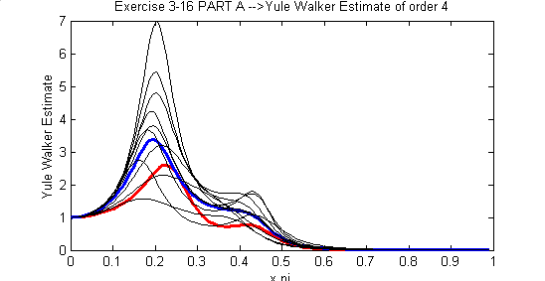

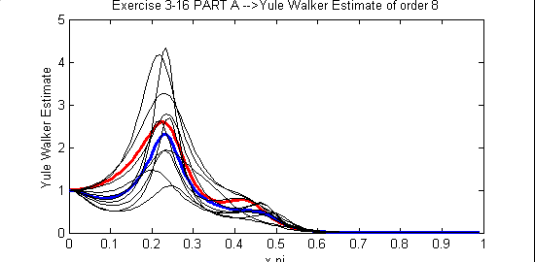

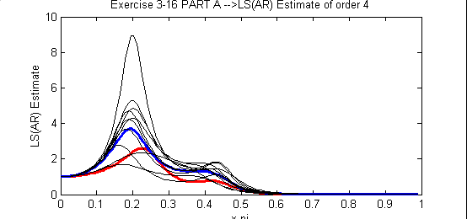

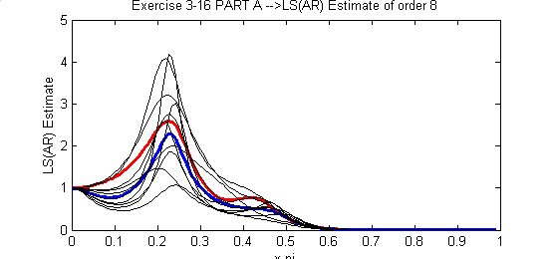
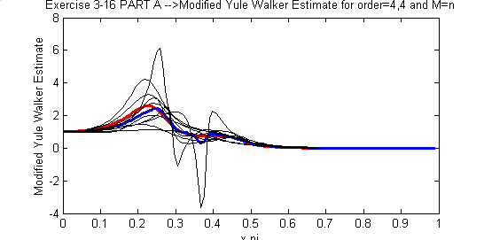

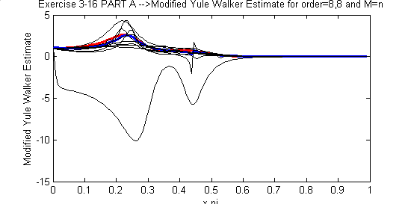

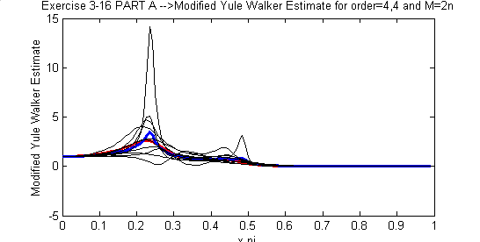

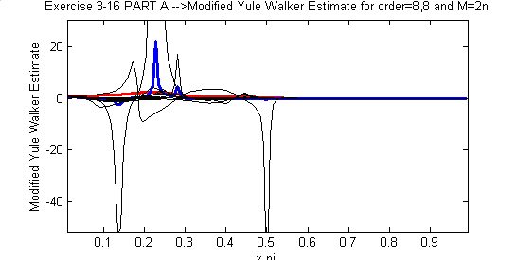

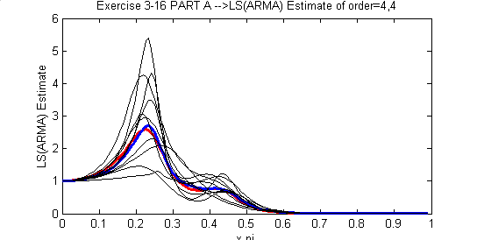

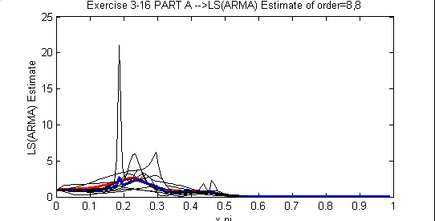

Pole-Zero Plots

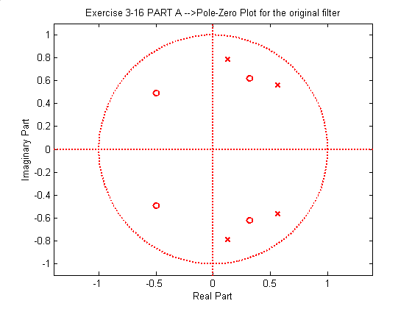
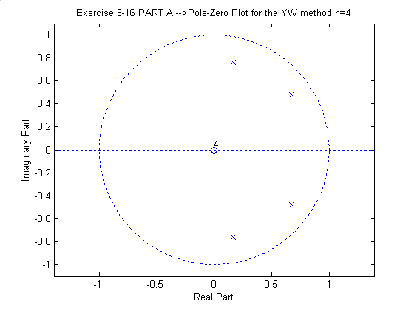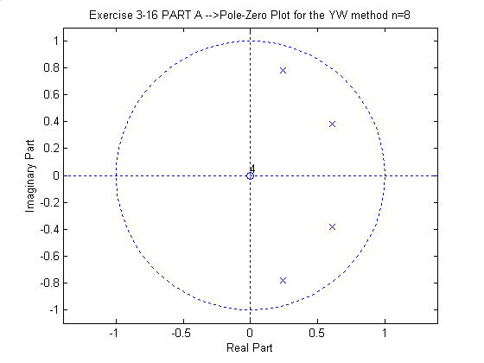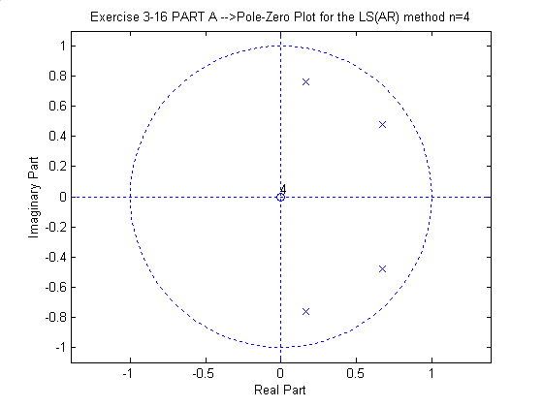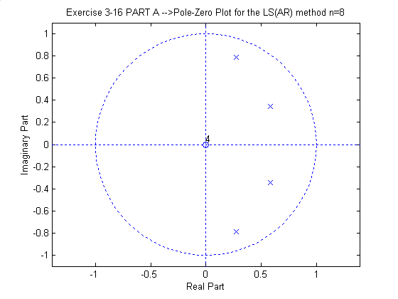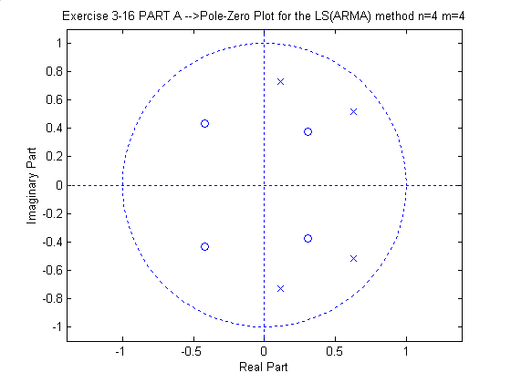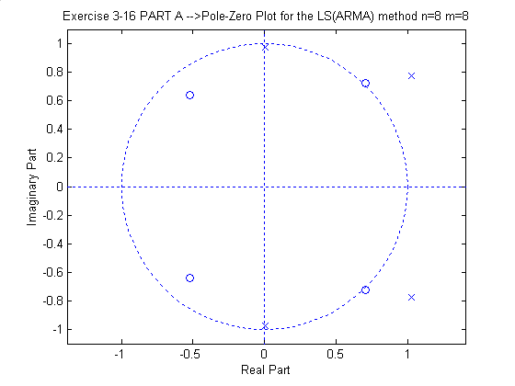

(b) It is observed that the PSD estimates of the YW method and the LS method nearly coincide for this data length. In addition, the poles and zeroes of these methods are nearly same. This is due to fact that the matrices used in YW method are unbiased estimates of covariance matrix as the number of samples increases. However, we theoretically know that the YW method is guaranteed to be stable while the LS method is not. But it is easy to stabilize the LS method by reflecting the unstable poles inside the unit circle. Moreover, the LS method is found to be more accurate then the YW method by the analysists.
(c) It is seen that the MYW algorithm is not guaranteed to produce non-negative PSD estimates. This is a serious drawback of MYW algorithm. On the other hand, the non-negativeness of the LS(ARMA) method is guaranteed.
Theoretically, ARMA spectral estimation methods are not well established and global convergence of these algorithms are not guaranteed. In these experiments I also observed that the statistical accuracy of both algorithms are poor. I run tests several times and observed that, in some tests the methods give good results but in some they diverge.
In the LS(ARMA) model, the estimate is biased.
In the MYW method it is observed that, increasing M value does not help the results. Theoretically, if the real poles and zeroes of the system are close to the unit circle, increasing M makes the estimation worse.

(d) In the following figures the LS(ARMA) estimates based on ARMA(4,4) model for K=4,8,12,16 are given. By looking at the figures it not easy to discuss the effect of K on the performance of the estimator since all four estimates are good. Also the zeros of the real model are not so close to the unit circle, therefore the bias problem is not severe. Actually, I conduct the experiment several times and observed same characteristic. However, theoretically the bias of the LS(ARMA) estimate can be reduced by increasing the K value.

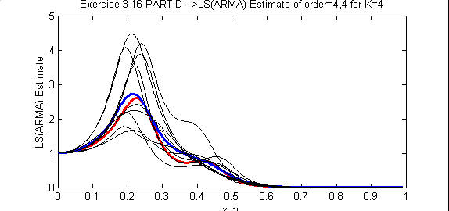
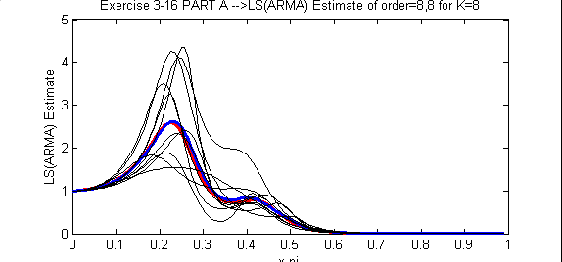

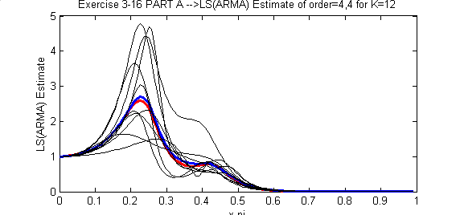

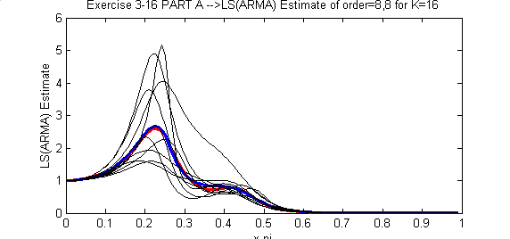

(e) In AR estimation methods, YW and LS, increasing the order improves the performance. This is due to the fact that, approximating an ARMA process of order (4,4) with an AR process should be conducted with larger order (Pade approximation). But one should note that, for a stable ARMA model, the approximate higher order AR model is not necessarily stable. Also the variance of the estimate for higher orders increases. This is due the fact that, for higher order estimation, higher correlation lags are used in the estimation. These high correlation lags may not be stable and cause unstable coefficient estimation.
In ARMA estimation methods the problems discussed above is easily identified. We see that in the LS(ARMA) method the poles and zeroes are inside the unit circle for order=(4,4). However some poles are outside the unit circle for order=(8,8) causing an unstable estimate. The same discussion holds for MYW method.

(f) AR estimates are better than MYW_ARMA estimates for this experiment. However, LS(ARMA) estimate for order=(4,4) is better than LS(AR) & YW estimates of order 8. But still, the stability of this method (LSARMA) is questionable.
The ARMA estimates of order=(8,8) are worse than AR estimates.

(g) In the following figures the periodogram PSD estimates (with and without Bartlett window) of this ARMA process is given. The estimates are averages of 50 realizations. The number of samples is again chosen as 256.
It is seen that the variance of the periodogram estimate is huge wrt parametric estimation methods. However the resolution of the periodogram method is better than the parametric estimation methods discussed. It is not easy to observe this fact from these experiments, because this a broadband process and the spectral separation between the peaks is not small. We’ll discuss this fact in the second part of this exercise where we conduct the same experiments on a narroe-band ARMA process.

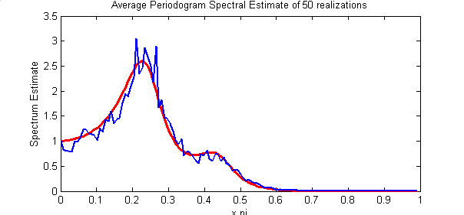

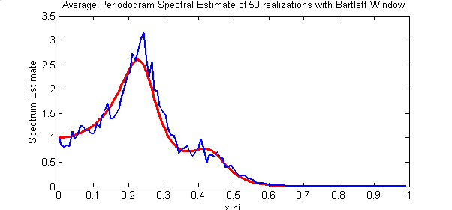

Part 2 : Narrowband ARMA Process:
The filter coefficients of the narrowband ARMA process are given as follows:
a(1)=1 ; a(2)=-1.6408 ; a(3)=2.2044 ; a(4)=-1.4808 ; a(5)=0.8145;
b(1)=1 ; b(2)=1.5857 ; b(3)=0.9604 ;

IMPORTANT: Many of the comments made at the first part of this exercise on broadband ARMA process is true for narrowband process. Therefore, I will not mention tham again. Instead I will focus on different discussions that are observed for this specific case.

(a) PSD estimation will be conducted with the following four processes: AR(4), AR(8), AR(12), AR(16) ARMA(4,2), ARMA(8,4), ARMA(12,6) and the four methods: Yule Walker & Least-Squares for AR processes; Modified Yule Walker & Two Stage LS for ARMA processes.

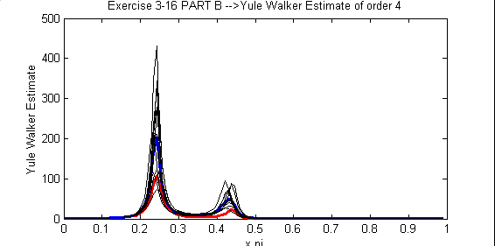

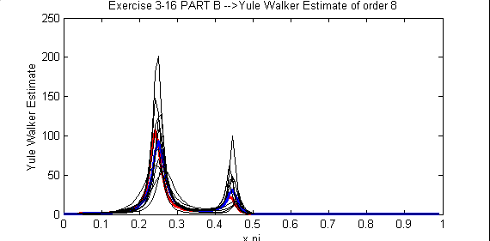

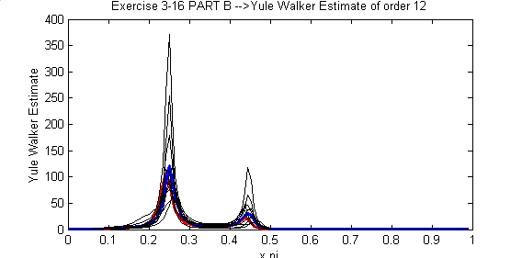

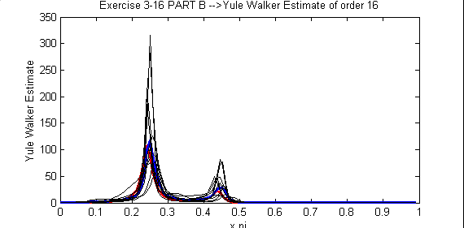

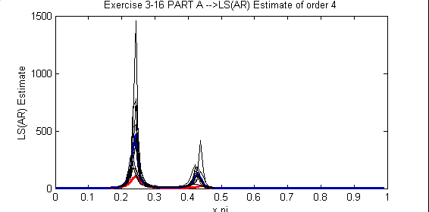
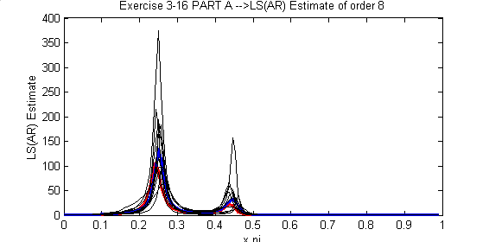

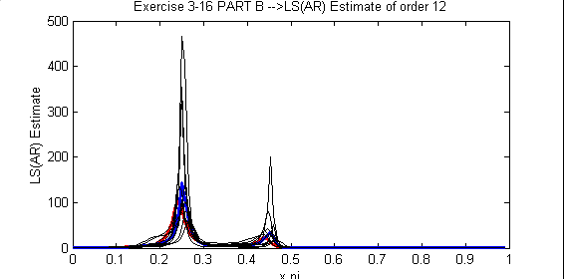

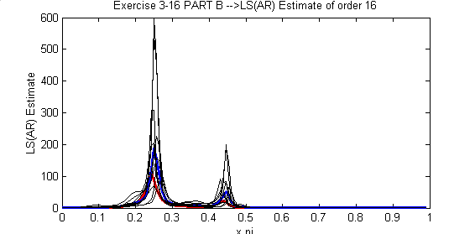

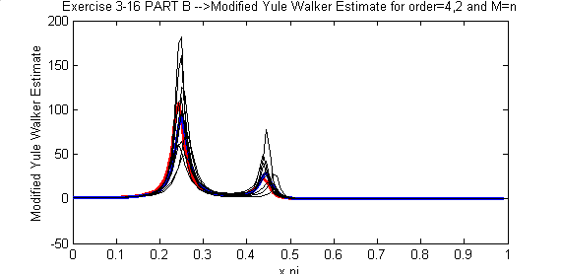
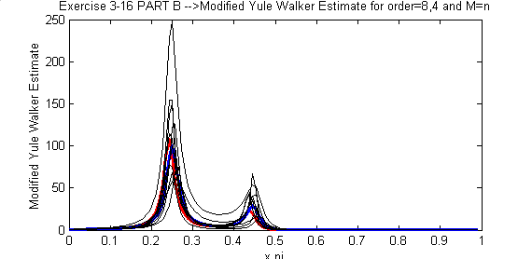

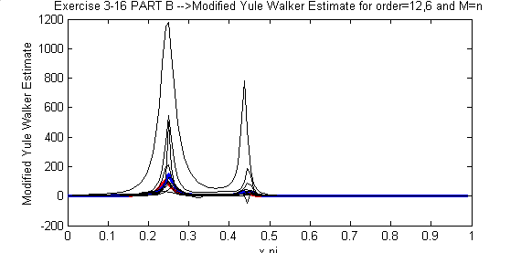

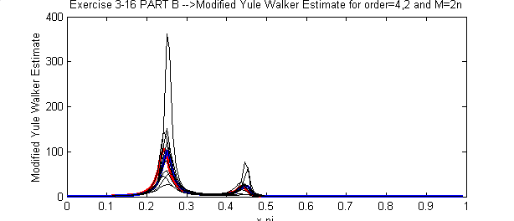

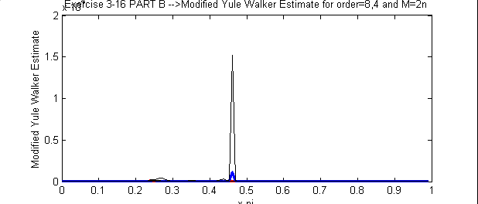
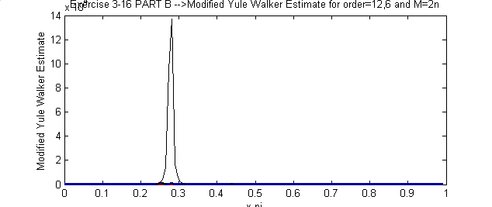

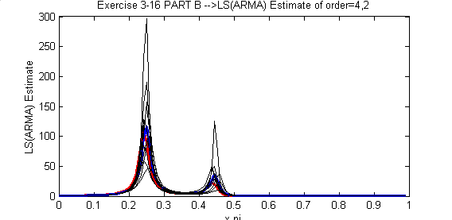

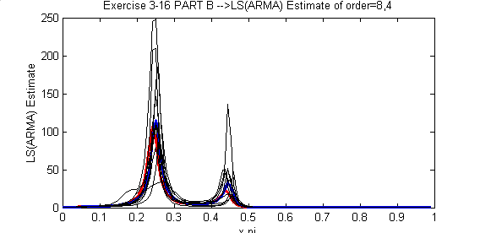

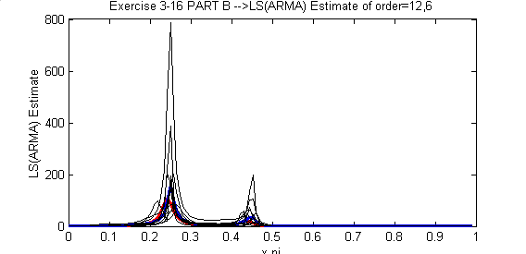

Pole Zero Plots

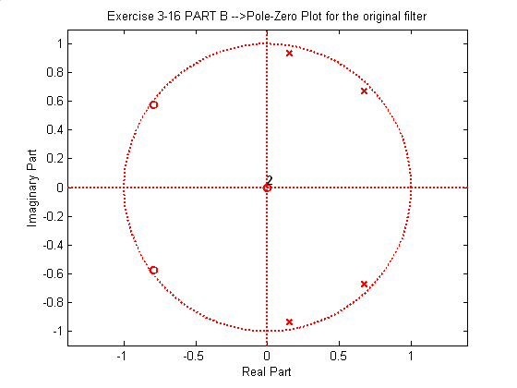
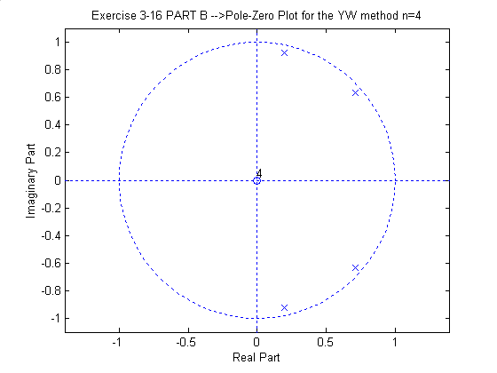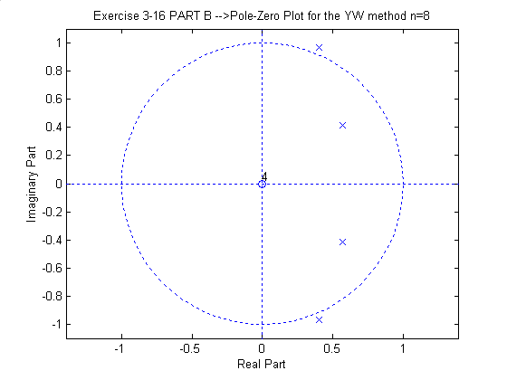
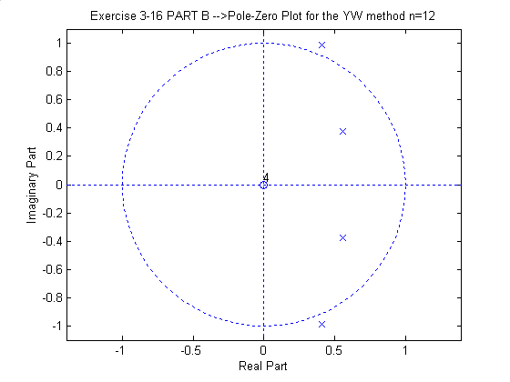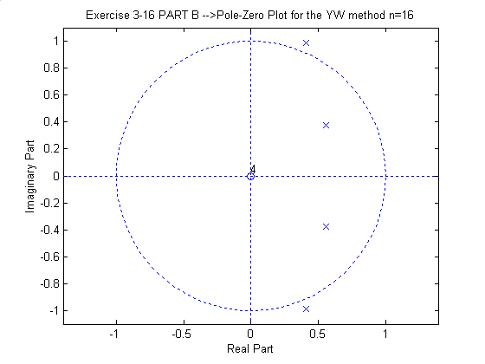
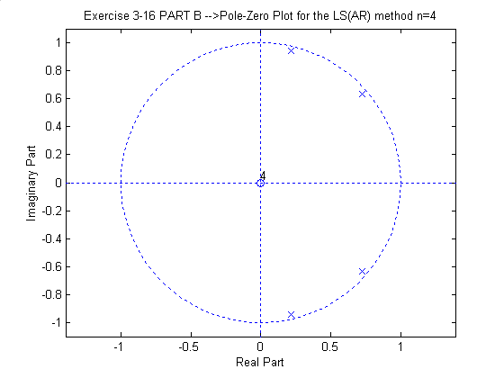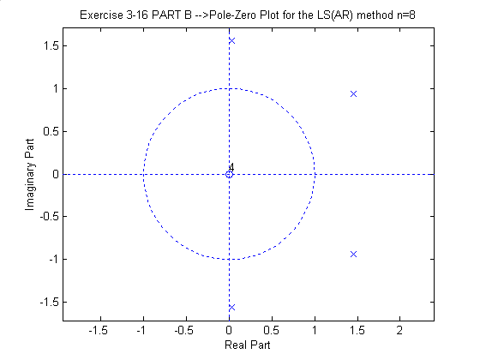
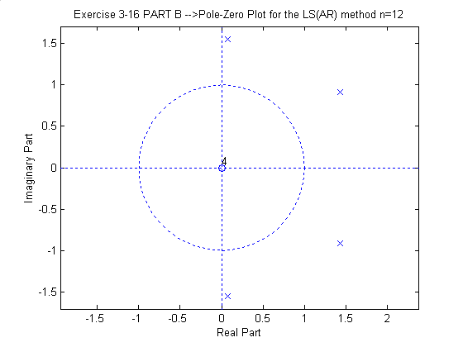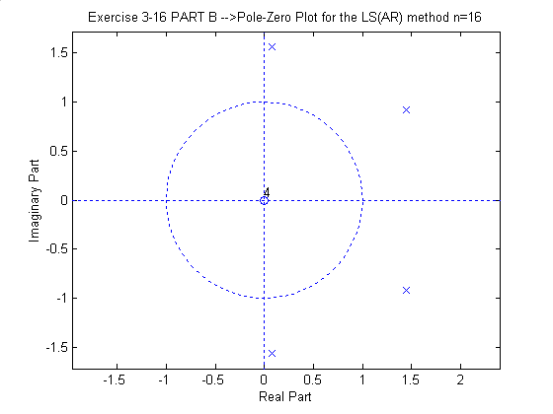
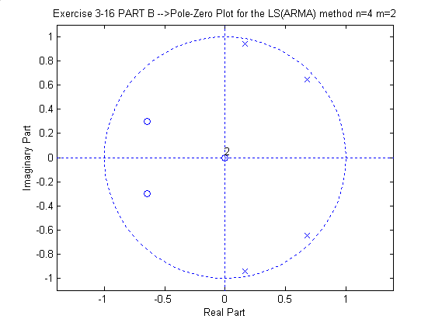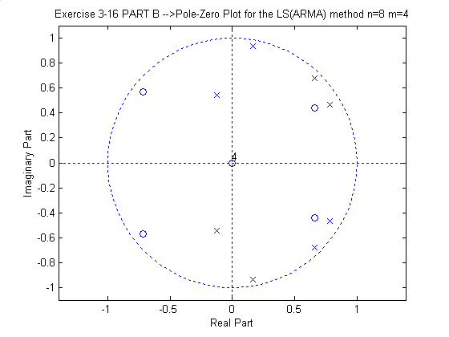
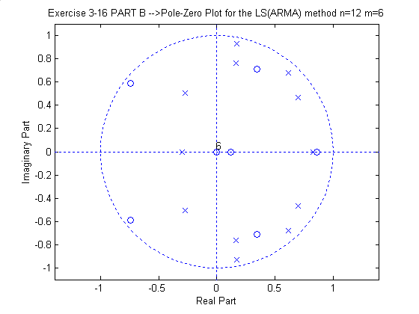

(b) Two AR algorithms nearly coincide as we discussed in broadband case. However, the YW AR estimate seemed to perform better. This may be due to the fact that LS estimate is not guaranteed to be stable.
(c) The same discussion for broadband case holds except, the MYW algorithm seem to perform better for true system orders (4,2). Increasing M does not help again.
LS(ARMA) method give better results wrt MYW algorithm
(d) In the following figures the LS(ARMA) estimates based on ARMA(4,4) model for K=4,8,12,16 are given. It is observed that the estimates get better as K increases. This is due to the theoretical fact that the bias of the LS(ARMA) estimate can be reduced by increasing the K value. Since, the zeros of the system is close to unit circle, the bias problem is considerable.

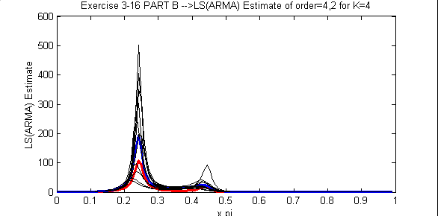

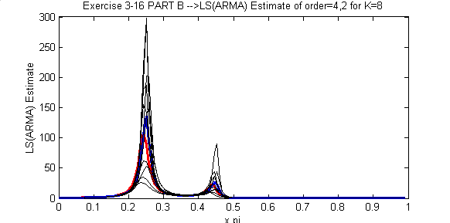
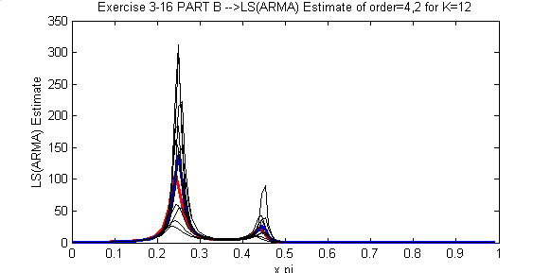

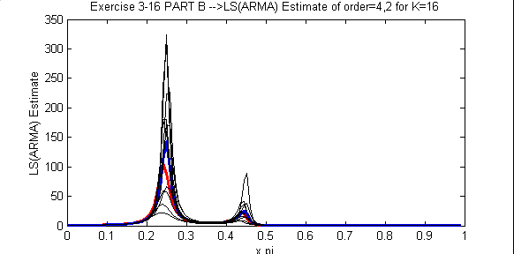

(e) We see the effect of increasing order clearly from the pole-zero plots of the AR estimates. As the model order increases, the stability of the estimates decreases. The narrowband process can readily be expressed by true system orders different from the broadband case. Therefore increasing the order causes ambiguity due to the fact discussed in Pade approximation exercise.
Increasing the order in ARMA estimates degrades the performance.
(f) AR model estimates are better than ARMA estimates for proper order selections. This is due to the fact that AR models can model sharp peaks better as visualized in this exercise.
(g) The periodogram spectral estimate can resolve the spectral peaks with Bartlett window size=number of samples. And the stability of this estimate is better. However the variance of the estimate is severe wrt parametric methods. Also if we decrease the size of the Bartlett window the resolution will significantly decrease.
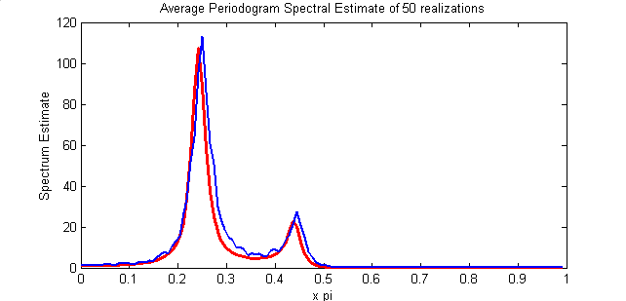
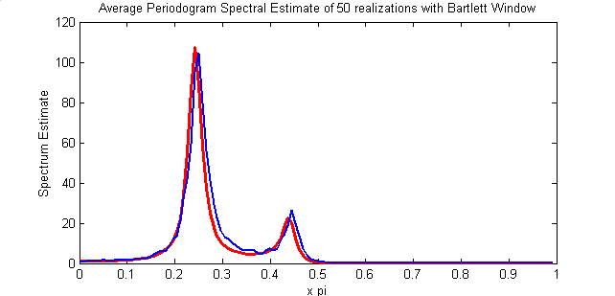

Difference between narrowband-broadband performances of the algorithms:
It is observed that for proper order selection, both AR and ARMA methods can estimate the broadband and narrowband PSD within a scale of performance. The ARMA methods performed better in spectral valleys while AR methods were better in modeling sharp spectral peaks. ARMA estimation methods were more precise in estimating narrowband ARMA process than broadband. This is true for the AR methods as well.

Exercise C3.17: AR and ARMA Estimators for Line Spectral Estimation
(a)
The sequence under concern is:
y[n] = 10sin(0.24πn+Φ₁) + 5sin(0.24πn+Φ₂) + e[n]
e[n]: White Gaussian Noise with variance : σ² ;
Φ₁ & Φ₂ are independent random variables uniformly distributed on[0,2π]
Spectrum of y[n] is given as:
Φ(w) = 50π[δ(w-0.24π) + δ(w+0.24π)] + 12.5π[δ(w-0.26π) + δ(w+0.26π)] + σ²

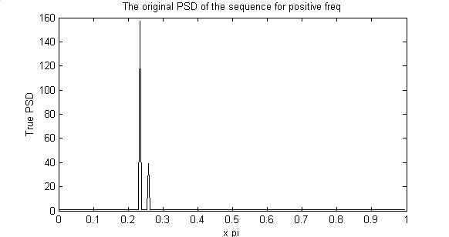

(b)
The true AR polynomial is computed using the ACS. The ACS function is found to be:
r_true(k)=50*cos(0.24*pi*k)+12.5*cos(0.26*pi*k)
Using this ACS, AR(4), AR(12), ARMA(4,4) and ARMA(12,12) models are used for PSD estimation. The following figures give these estimates. The theoretical discussion is given after the figures.
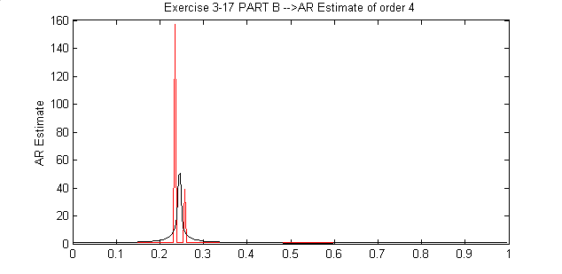

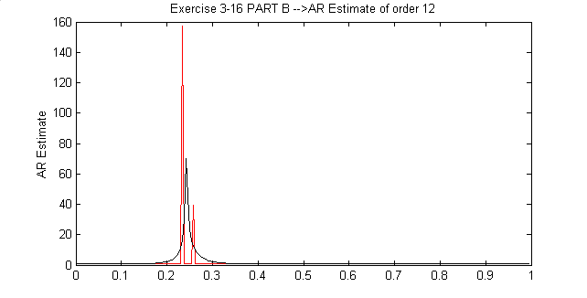
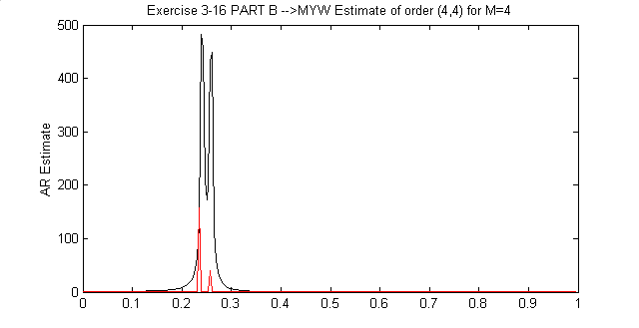

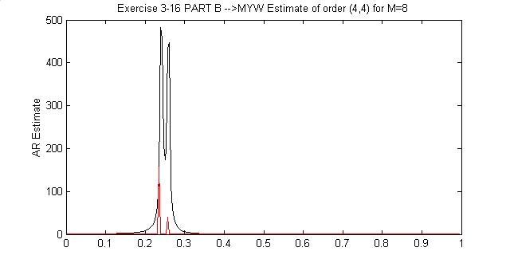

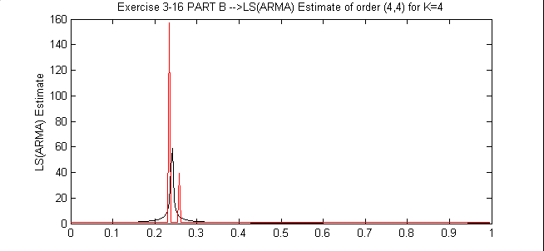

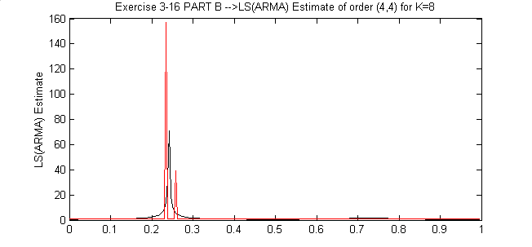

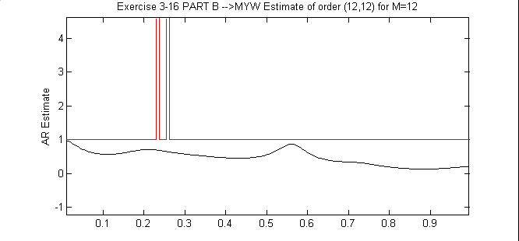

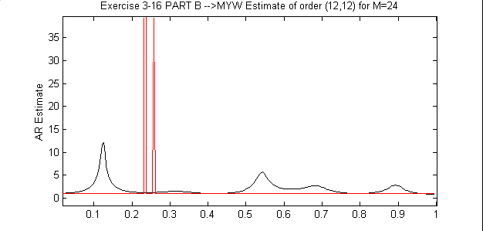

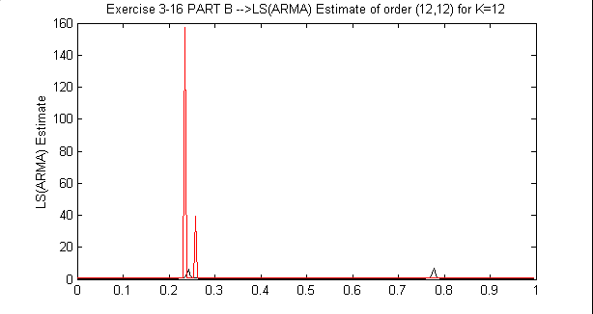

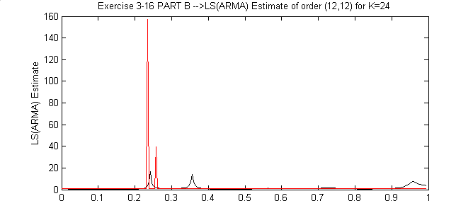

It is observed that only MYW ARMA estimation method is able to resolve the spectral peaks for order (4,4). However, I observed that the YW method can also resolve the spectral peaks for larger orders (for example 24). I could not observe any performance change for larger values of M and K. The zeros of some estimate models are given in the tables below. It is seen that the MYW method locks on the correct frequency estimates of the two sinusoids. Other methods can only lock to one frequency or diverge at all.
The true angles are 0.24*pi and 0.26*pi
Roots for AR(4) with YW method
Roots | Corresponding Angles (*pi)
0.7172 + 0.6915i | 0.2442
0.7172 - 0.6915i | -0.2442
-0.4802 + 0.4269i | 0.7687
-0.4802 - 0.4269i | -0.7687

Roots for AR(12) with YW method
Roots | Corresponding Angles (*pi)
0.8695 | 0
0.7176 + 0.6866i | 0.2430
0.7176 - 0.6866i | -0.2430
0.6079 + 0.6534i | 0.2615
0.6079 - 0.6534i | -0.2615
-0.0166 + 0.8538i | 0.5062
-0.0166 - 0.8538i | -0.5062
-0.4316 + 0.7122i | 0.6734
-0.4316 - 0.7122i | -0.6734
-0.8199 | 1.0000
-0.7175 + 0.4028i | 0.8372
-0.7175 - 0.4028i | -0.8372

Roots for MYW_ARMA(4,4) for M=4
Roots | Corresponding Angles (*pi)
0.6845 + 0.7290i | 0.2600
0.6845 - 0.7290i | -0.2600
0.7290 + 0.6845i | 0.2400
0.7290 - 0.6845i | -0.2400

Roots for MYW_ARMA(12,12) for M=12
Roots | Corresponding Angles (*pi)
-1.1873 | 1.0000
-0.8452 + 0.9059i | 0.7390
-0.8452 - 0.9059i | -0.7390
1.0157 + 0.7565i | 0.2038
1.0157 - 0.7565i | -0.2038
1.1489 | 0
-0.1736 + 0.8655i | 0.5630
-0.1736 - 0.8655i | -0.5630
0.3252 + 0.6001i | 0.3419
0.3252 - 0.6001i | -0.3419
0.0878 + 0.4442i | 0.4379
0.0878 - 0.4442i | -0.4379

Roots for LS_ARMA(12,12) for K=12
Roots | Corresponding Angles (*pi)
20.4546 | 0
0.7206 + 0.6850i | 0.2420
0.7206 - 0.6850i | -0.2420
0.7478 | 0
0.1772 + 0.7846i | 0.4293
0.1772 - 0.7846i | -0.4293
-0.2428 + 0.7772i | 0.5964
-0.2428 - 0.7772i | -0.5964
-0.6696 + 0.5397i | 0.7841
-0.6696 - 0.5397i | -0.7841
-0.8322 | 1.0000
-0.5055 | 1.0000

(c) From the following figures it is observed that, LS(AR) for order=4, MYW_ARMA for order=(4,4) and LS(ARMA) for order=(4,4) can resolve the spectral peaks. The pole-zero plots support these observations. The process is an AR process of order 4 in the limiting case. Therefore, it is expected to have better performance for models having an order of 4.

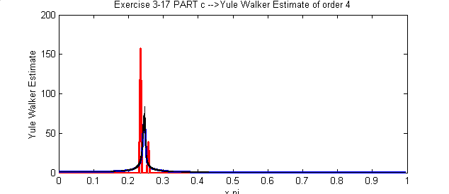

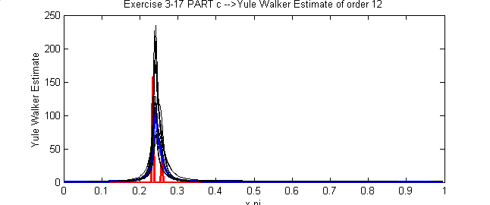

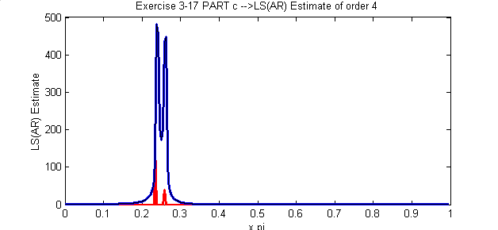

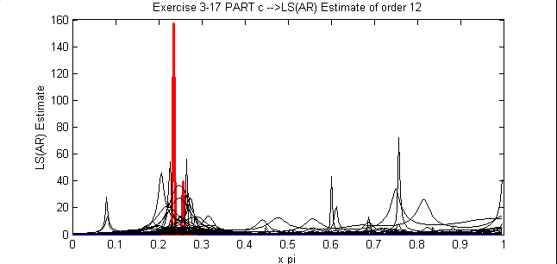

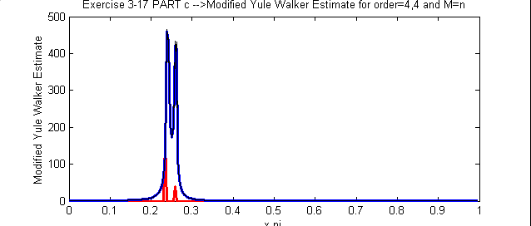

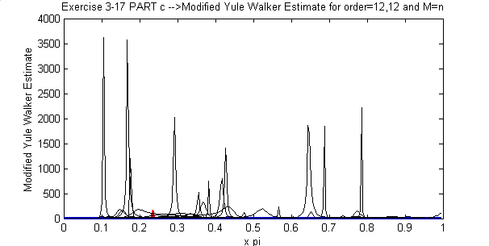

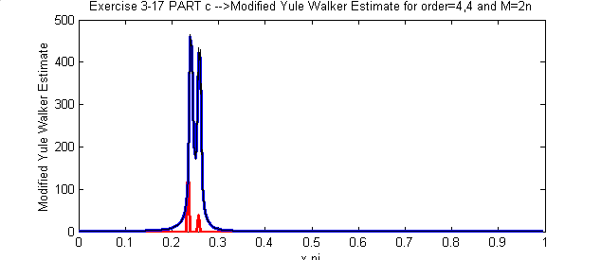

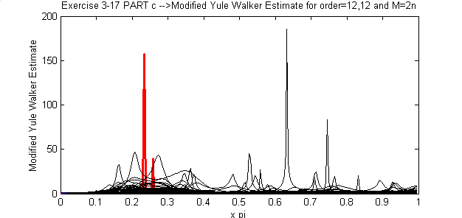

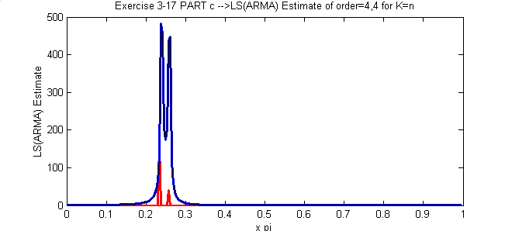

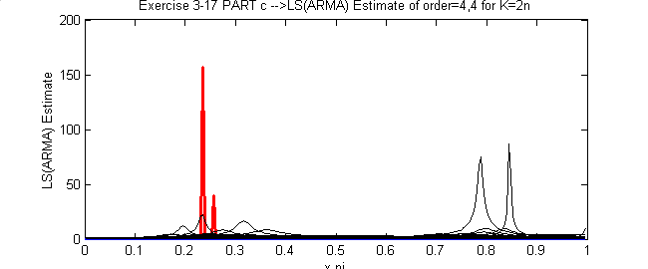

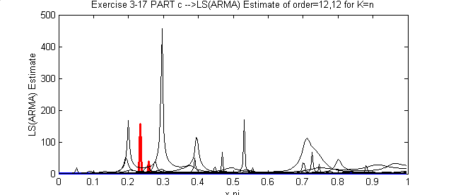

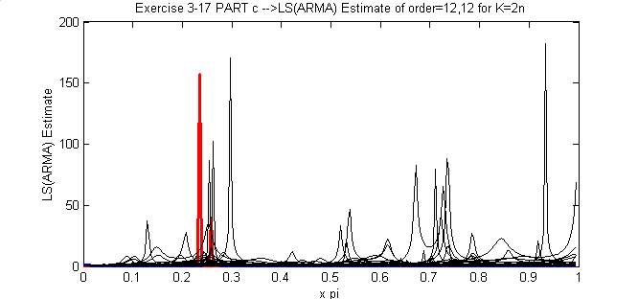

Pole Zero Plots
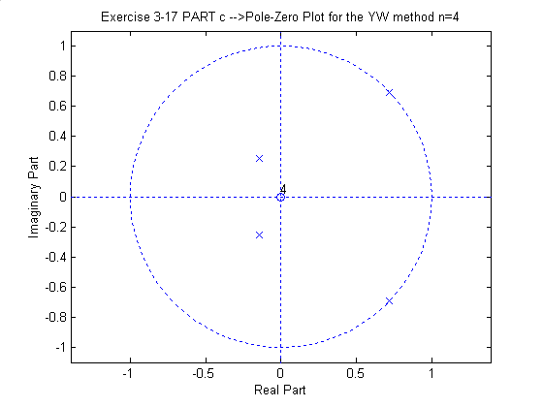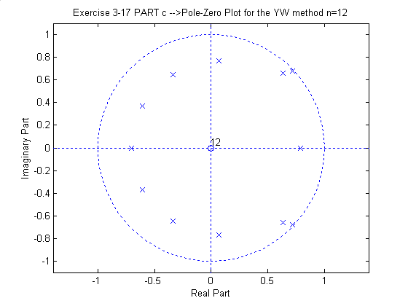
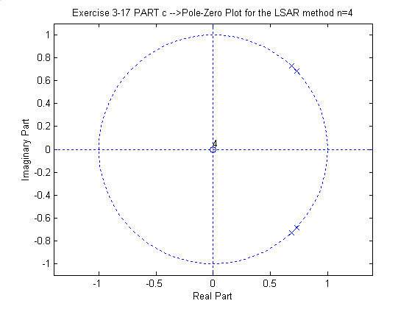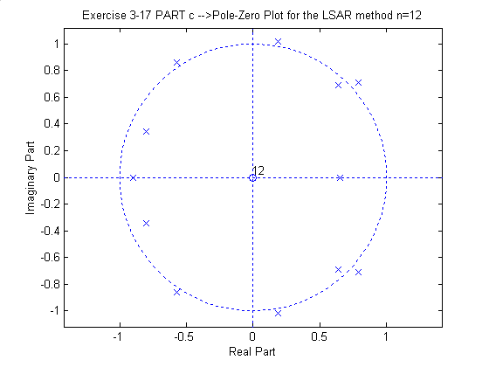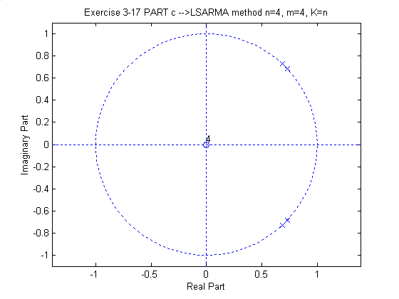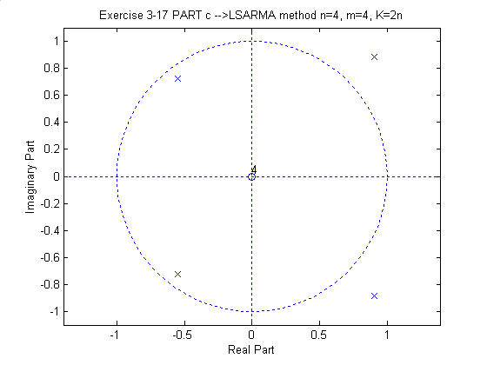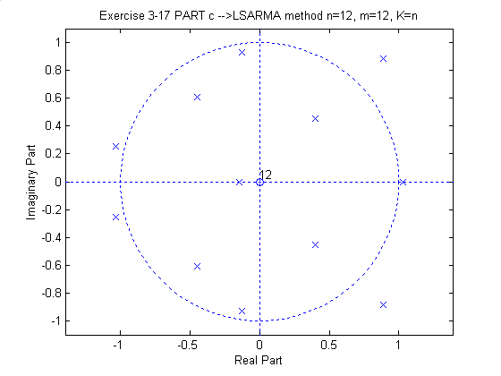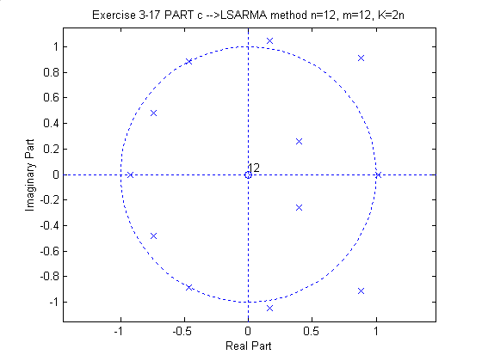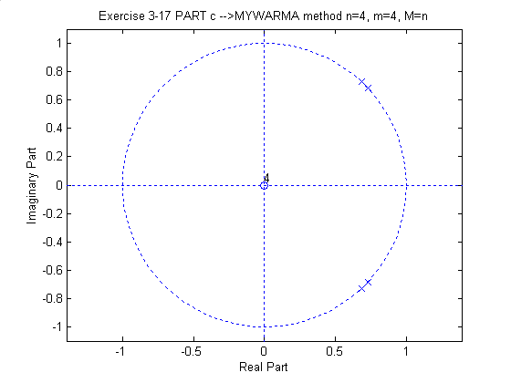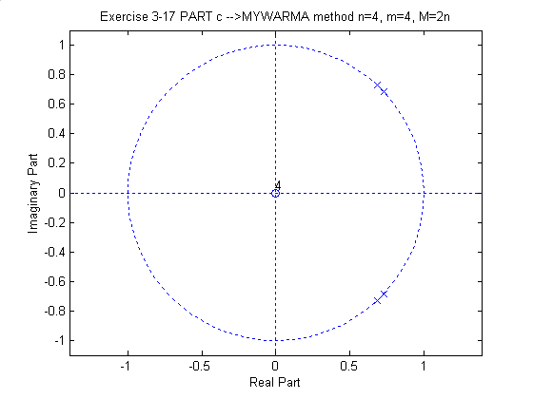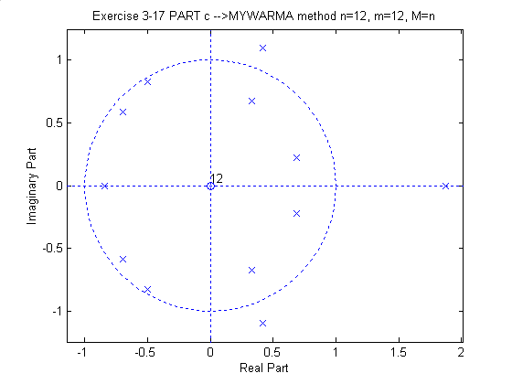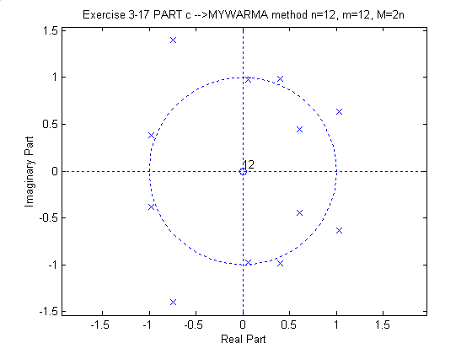

(d) The following figures illustrate AR and ARMA estimators for noisy process. From the figures and pole-zero plots, we observed that only high order AR and ARMA estimates (for example 32) are able to resolve the two sinusoids. However when we increase the model number some spurious sinusoids apper in the figures (look at MYW and LSARMA figures for order 32). From these methods, LSAR and LSARMA seem to have better resolution characteristics.

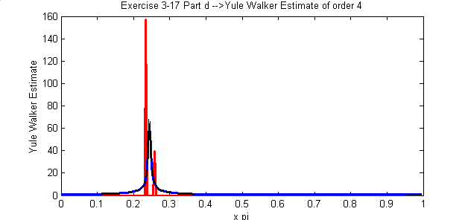

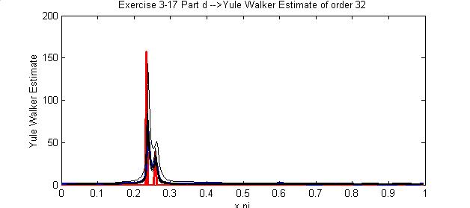
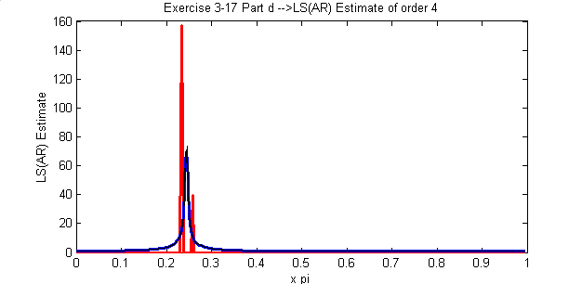

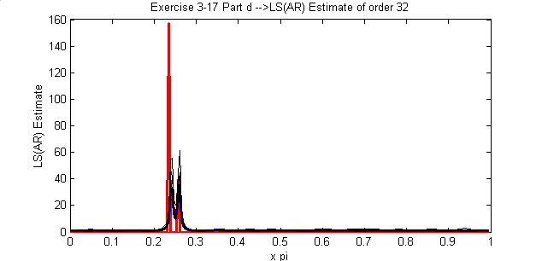

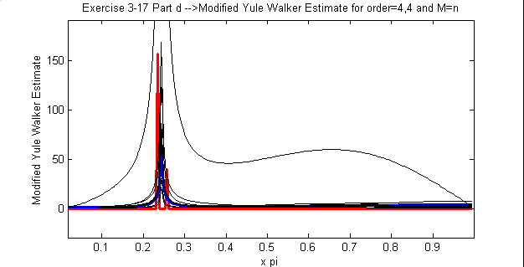

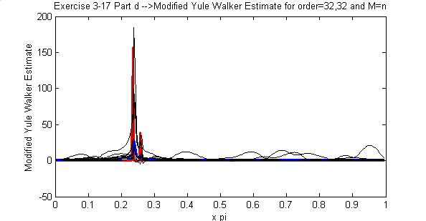

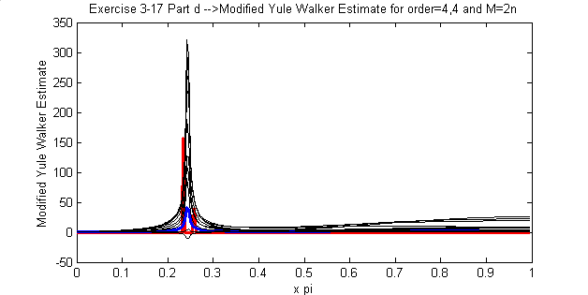

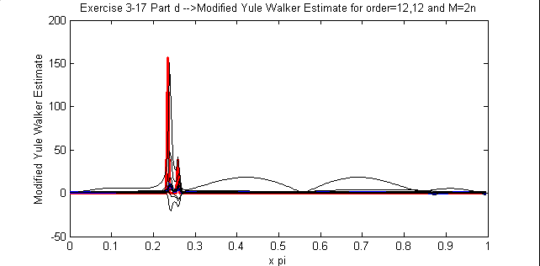

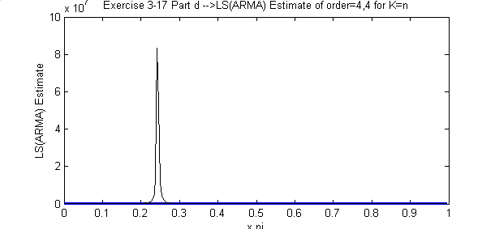

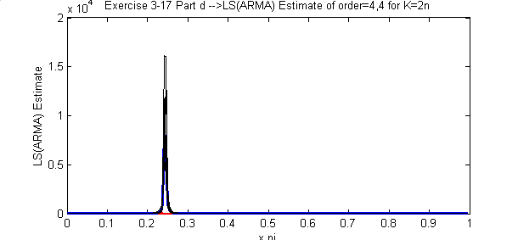
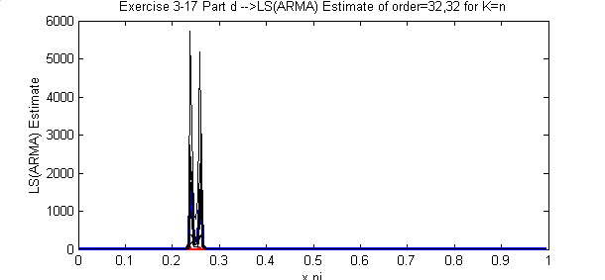

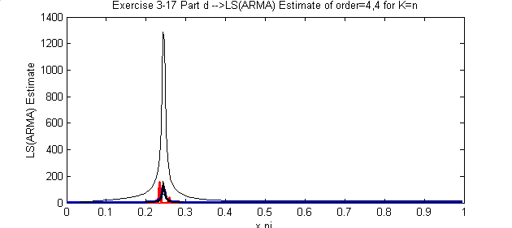
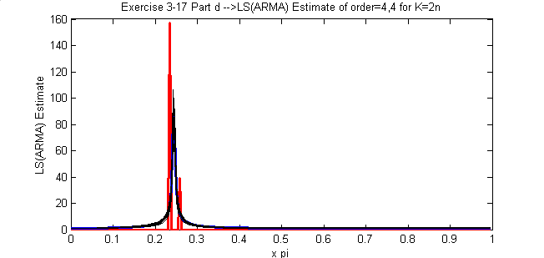

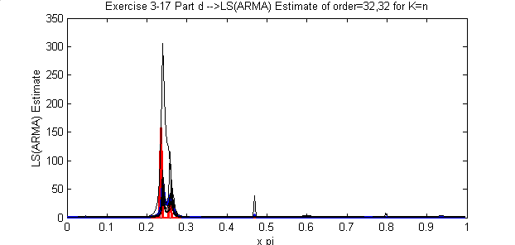

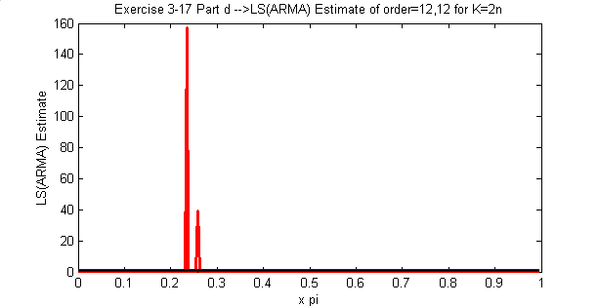
Pole-Zero Plots

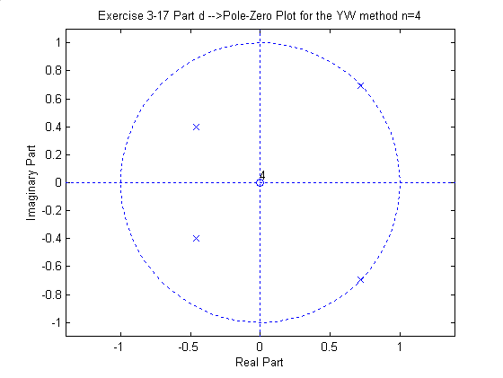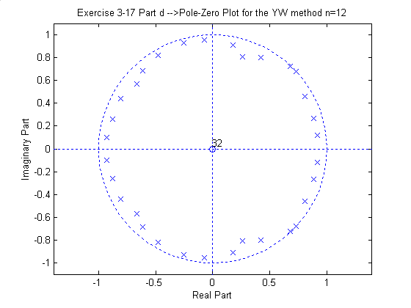
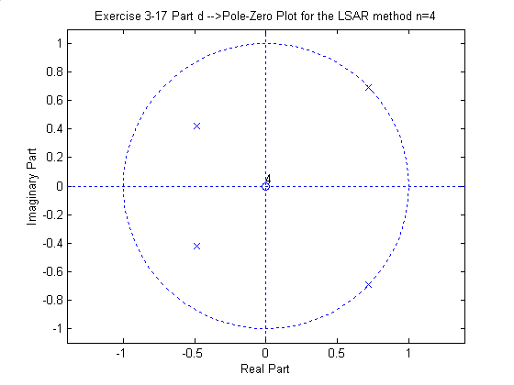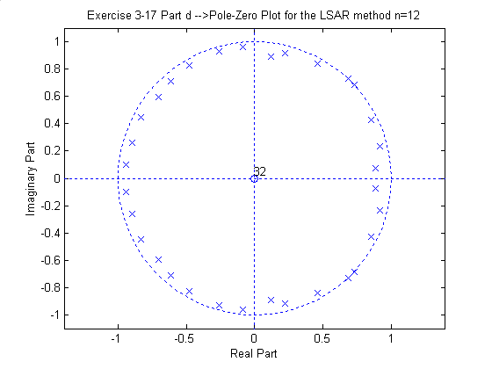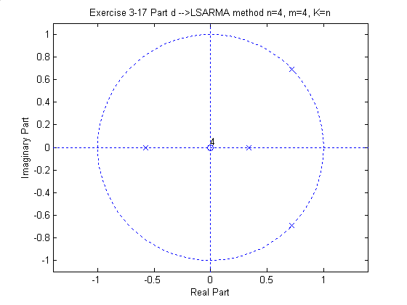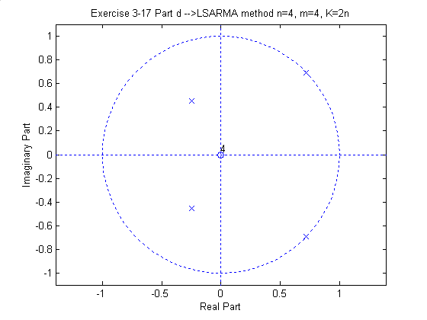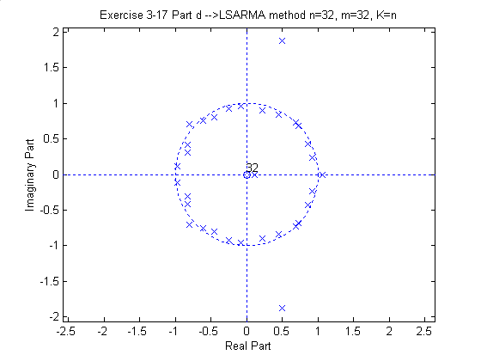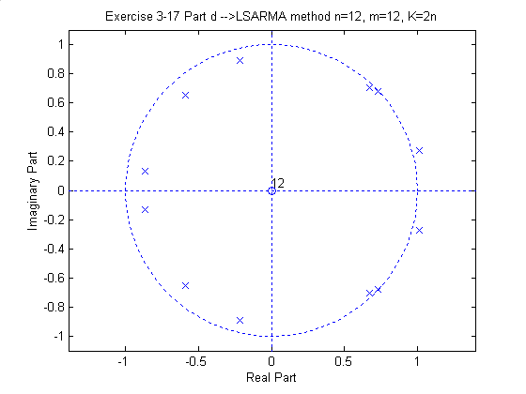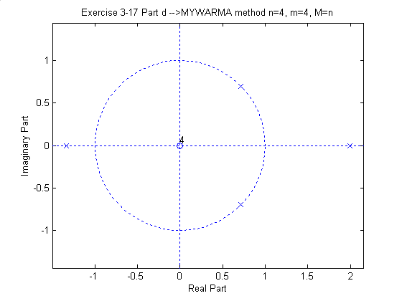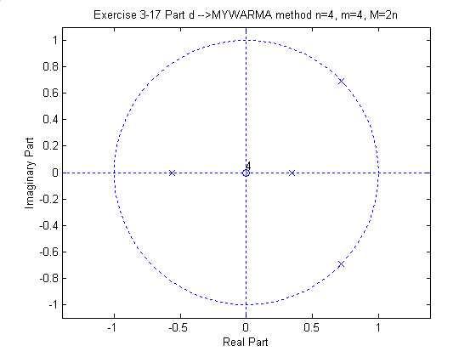
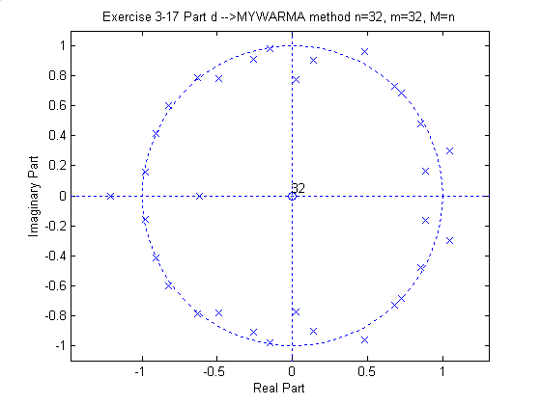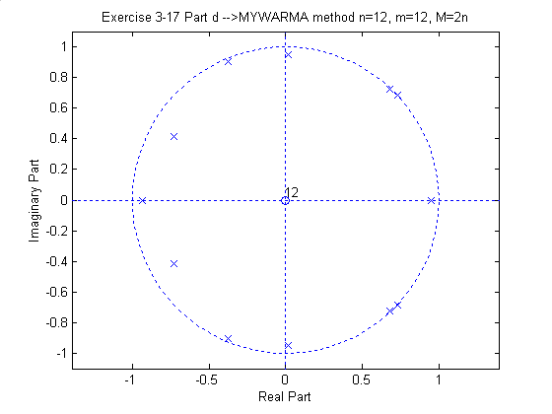

(e) The periodogram spectral estimates with different Bartlett window sizes is given in the below four figures. It is seen that for small and mid BT window size resolution is not good. However for full BT window size (data length) the spectral resolution is better than parametric methods. For this window size the variance is also better.

